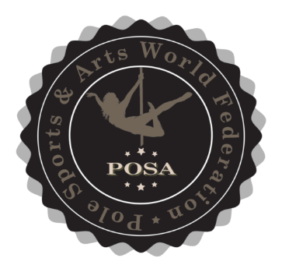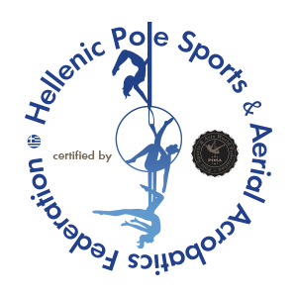

I acknowledge that both my coach and I have read, understood, and agreed to the Posa World Federation Rules and Regulations. I have also read the Posa World Federation Code of Ethics 2026 and agree to abide by them. I understand that failing to comply may result in disciplinary action.
All athletes participate in POSA competitions at their own risk and acknowledge that any injuries or accidents that occur during the event are their own responsibility. POSA does provide medical assistance in the case of injury; however, the medical representative has the final authority to decide whether an athlete's injury disqualifies them from participating or continuing in the competition.
POSA is not responsible for any loss or damage to the belongings of athletes or officials.
By signing below, I also give permission to the Posa World Federation to use my photos for promotional and marketing purposes.
My signature below confirms that I fully understand and agree with the terms and conditions stated above.

Athlete Name ……………………………………………………………………………………
e-mail ……………………………………………………………………………………………..
Guardian Name ………………………………………………………………………………..
(if an athlete is under 18 years)
Date: ………………………………………………………………………………………………
Signature Athlete ……………………………………………………………………………….

